JECRC
Affi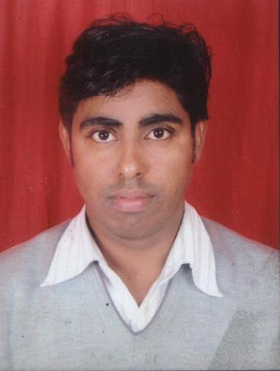x and Attest
passport
size photograph
JAIPUR

INDIVIDUAL TECHNICIAN DATA SHEET
Name of the Technical staff member | : | Birsingh Sirowa
Present Designation | : | Lab Instructor
Email Id: :birsinghsirowa.it@jecrc.ac.in
Contact Details :9214009285

I. Particulars of Educational Qualification: (only completed)

Category | Name of the Degree | Specialization | Year of Passing | Name of the College | Name of the University
UG | BA | Arts | 2003 | Govt college, Bawal | MDU,rohtak
PGDCA | PGDCA |  | 2005 | Gurukul Edu. Institute ,Kota | JRN vidyapeeth
PG | MCA |  | 2014 |  | JNU,Jaipur

II. Academic Experience : 12 Year

III. Industrial Experience :

